O. Zhlobinskaya

Presidential Library

Saint-Petersburg, Russia

**Archival description using UNIMARC:   
Presidential Library experience**

The Presidential Library in Saint-Petersburg, one of the three national libraries in Russia, was opened in May 2009, so next year we are going to celebrate our first 10 year anniversary. It was established as a nationwide repository of digital materials either digital born or digital copies of the most important documents on the history, theory and practice of Russian statehood and Russian language.

First library collection was based on digitized materials of Russian State Historical Archive. Now among the main sources of acquisition are Russian State Historical Archive, State Archive of Russian Federation, regional archives of the country, Russian national libraries and major research libraries of the country. By the end of 2018 our collection includes about 660 000 items, and more than a half of our collection are archival materials.

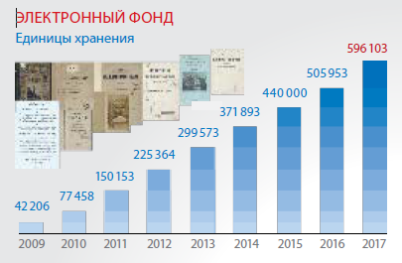

**Digital collection**



**658 000**

2018

**November**

Digital collection of Presidential library (2009 – 2018)

The format we use both for cataloguing and for exchange is RUSMARC which was developed as national implementation of UNIMARC taking into account specifics of national practice and some differences existing between ISBD and Russian Cataloguing Rules.

Since most of the Presidential Library collection consists of archival materials, one of the most important tasks to be solved from the very beginning of the library was description of such kind of materials. How to describe them? And how to maintain archival records – either to make separate catalogue or to include them into the integrated library catalogue? It is evident that archival and library materials are quite similar by nature in that they document human history. But due to different traditions, standards and practice of description archival materials are often not listed in library catalogues. On the other hand, inclusion of archival catalogue records in integrated online catalogs would enable many users to locate archival resources more easily.

In 2010 Presidential Library established Working group [to develop the principles and approaches to integrated presentation and access to library, archival, museum resources in compliance with modern international standards](https://www.prlib.ru/en/interdepartmental-working-group). The Working group included representatives from major libraries and archives of the country (Presidential library, National Library of Russia, Russian State Library, Russian State Historical Archive, State Archive of Russian Federation), National RUSMARC Service, National Library Information Centre “LIBNET”, library and archival software vendors (DIT-M, AS Company, Alt-Soft Company). Main objectives of the WG were:

* to analyze national and world practice of archival description as well as international standards and machine-readable formats in the field;
* to define data elements for different levels of archival description (fonds-series-file-item);
* to develop specific requirements for archival description in the library;
* and finally – if necessary, to develop appropriate updates to RUSMARC format for archives.

The Working group studied major international standards for archives.Threeof them – *General International Standard Archival Description (ISAD (G))*, *ISAAR (CPF): International Standard Archival Authority Record for Corporate Bodies, Persons and Families*, and*Encoded Archival Description* (EAD) tag library were translated by Presidential Library and published in Russian for local users. On the national level in Russia we did not have (and still do not have) national standard for archives, just recommendations and general regulations issued by the Federal Archival Agency, and practice used in the country might vary from one archive to another.

As for the libraries, major standards used are ISBD (in Russia – Russian Cataloguing Rules) and MARC formats. MARC formats were not supposed to be used for archives and in general they do not allow to create detailed archival description but nevertheless they still can be used for specific purposes.

Many researchers note that unlike bibliographic record, which usually focuses on an individual manifestation of a published work, an archival description is highly hierarchical and typically it involves a complex group of interrelated unique materials whose shared provenance and hierarchical arrangement must be shown very clearly. MARC record which gives just a horizontal view of the object is not the best instrument to describe archives. But in fact UNIMARC users are lucky because UNIMARC and UNIMARC-based formats have the mechanism of building comprehensive multilevel descriptions and establishing links between different levels.

Comparative study of UNIMARC and ISAD(G) showed that UNIMARC lacked some data elements which were essential for archives. Based on the results of Working group activities, in 2012 we submitted proposals to Permanent UNIMARC Committee to make changes and additions in UNIMARC which we supposed to be necessary for archives. After discussion most of these proposals were approved by PUC, and later the same updates were made in RUSMARC. Also draft of Guidelines for archives in UNIMARC was developed (unfortunately, it has not been finalized yet).

The Guidelines give the principles of using UNIMARC in presenting archival materials, list data elements that could be commonly included in the description of archives and indicates where each data element would be placed in a UNIMARC record. Section 4 gives examples of full records for archives. Appendix A contains Table of correspondence of EAD elements/attributes and UNIMARC which includes the most significant EAD elements mapped to UNIMARC fields.

General principles documented in these Guidelines:

(1) Type of control

First of all when archival descriptions are incorporated into library catalogues, we should be able to identify that this particular record describes archival material rather than traditional library documents. It would allow to implement different options of search, facet navigation and displaying search results to users. Materials might be defined as archival by the manner in which they are described, and here the most important is not the type of materials (text, photo, etc.) but the way by which materials are arranged, physically organized and handled by the custodian. Type of control is specified in the record label (character position 9).

(2) Multilevel description

Archival description is normally presented in a highly hierarchical structure proceeding from general description to more specific descriptions of its component, description of each part being linked to its higher unit.

Only information appropriate to the level being described must be provided. So such elements as material specific fields for photographs, maps, etc. would be used at item level.

In UNIMARC the whole hierarchy may be built using mechanism of linking entries (group of fields 46X). Though typically it is allowed inside a UNIMARC record to include relationships from the higher level to lower ones, in RUSMARC it is generally implemented to define relationships from the lower hierarchical level to the higher level (e.g. article to journal relationship, or, in case of archives – from file to series, or from series to fonds).

Archival description in UNIMARC can be constructed with any desired level of detail – it may be collection level, if it is sufficient, or it may be set of records for all desired levels.

Hierarchical level is indicated in the record label, character position 8. Additionally position of each described item within the hierarchy is identified explicitly – with field 251 Organization and arrangement of materials. Normally Standard terminology is used – fonds, series, file, item.

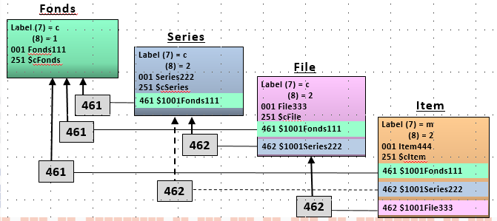

Multilevel archival description in UNIMARC

(3) Dates

According to ISAD(G) dates are one of essential elements in describing archives; any description of archival collection or part of the collection should always include date(s) when the documents in the collection (or part of the collection) were created. If any date is not known exactly, estimated date is given, and this is indicated in the description.

Most rules for archival description recognize dates of the collection as part of title, In UNIMARC record the dates may be entered into the field 200 Title and Statement of responsibility, subfields $j (*Inclusive dates*) and $k (*Bulk dates*). If the dates of creation are not considered as part of title – field 210 $d *Date of publication, distribution, etc.*, may be used.

Also dates are given in coded form in the field 100 General Processing Data, character positions 8-16.

These principles were taken as a foundation for archival description in Presidential Library and were included in the edition “Best practices for describing and indexing of digital copies” published in 2014.

Describing archival materials in the Presidential library is organized from the general to the specific. First collection level record for fonds is created, then – records for series, with automatic linking to fonds record via record identifier. Then – record for file or files, also with linking to higher level – series. In most cases it would be the fonds-series-file. But if necessary, item-level description may be created.

To avoid redundancy of information, at the highest appropriate level information that is common to the component parts must be present. Any repetition of information at lower levels of description, which has already been given at the higher level, is not allowed.

Main access point is normally created for the creator name (person, corporate body or family). All access points (personal names, corporate names, family names, geographical names, subject headings) at any level of description are controlled with the authority files which are common for library and archival materials.

Every record at any level is indexed with subject headings and classification indexes (Library Bibliographic classification). At fonds level creator is regarded as main subject, at series level main subject is the topic, which is normally written in the series title. At the file level main subject is defined depending on the content of items which are included in the file. Indexing at the item level is type-specific.

For example – record describing the file from the fonds of Department of Education (Russian State Historical Archive. Fond 733, Op. 206, D. 73). The file includes one document – map of Persia and Mesopotamia.

000 06822cmc2a2200000#x#450#

001 6ca00cb3-0a74-4abc-96e7-999e3d90f730

100 ##$a20150128l18401843k##l0rusy0189####ca

101 0#$ager

102 ##$aDE

120 ##$ab

121 ##$aa||aau#a#

122 2#$ad1840######$ad1843######

123 1#$aa

124 ##$aa$bd

200 1#$aКарта Персии и Месопотамии, составлена К. Циммерманом$j1840-1843 гг.

215 ##$a1 лист$cкарт.$d62х48 см

251 ##$cДело

300 ##$aЗаголовок на карте на немецком языке: West-Persien und Mesopotamien. C. Ritters Erdkunde, Buch 3. West-Asien. Iranische Welt, bearbeit von Carl Zimmermann, second Lieutenant im 21 Infanterie Regiment, herausgegeben durch C. Ritter und F. A. O Etzel. Berlin, Verlag v. G. Reimer, 1840-1843

300 ##$aБумага. Тушь, карандаш, акварель

461 #0$1001a74412a3-3cc5-4d21-8f0a-dfe2fbd9e72d$12001#$aДепартамент народного просвещения Министерства народного просвещения$1251##$cФонд$1852##$j733

462 #0$10019cc3627e-19b4-421e-a74f-17fa1dd1f54b$12001#$aГеографические карты со специальными обозначениями, относящимися к ведомству народного просвещения  
$vД. 73$1251##$cОпись$1852##$j206

605 ##$3LIBNET\UAF\0000076849$aРоссия – Иран: из истории взаимоотношений  
$lколлекция$2acquisition_Prlib

607 ##$3RU\NLR\AUTH\66476693$aМесопотамия (Западная Азия)$jКарты$2nlr_sh

607 ##$3RU\NLR\AUTH\6660241$aИран$jКарты$2nlr_sh

617 ##$aИран$2prlib_sh

617 ##$aИрак$2prlib_sh

617 ##$aСирия$2prlib_sh

608 ##$3DITM\AF\0000000386$aГеографические карты$2prlib_sh

686 ##$2rubbk$a26.89(533.5)я64$vLBC/M

686 ##$a26.17(533.5)$vLBC/M$2rubbk

686 ##$a26.89(5Ирн)я64$vLBC/M$2rubbk

686 ##$a26.17(5Ирн)$vLBC/M$2rubbk

801 #0$aRU$bРГИА$c20150128

801 #1$aRU$bГлавНИВЦ$c20150128$2rusmarc

852 ##$aРГИА$j73

The record above includes fields 120, 121, 123 and 124 (material specific data for maps), and also it is indexed with geographical subject headings (fields 607 and 617), form subject heading (608) and LBC class numbers.

The approach described helped to enhance users’ search interface.

After conducting the search in the catalogue the user may click specific tab to choose specific category of materials – library or archival.

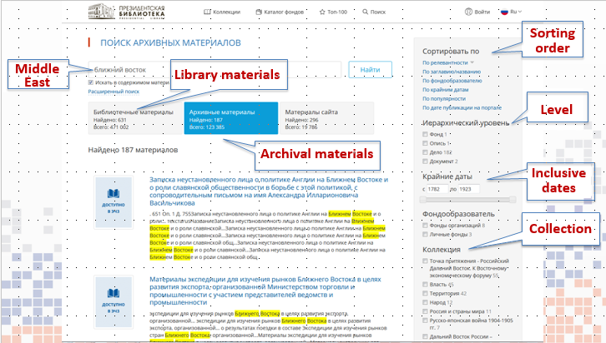

Both library and archive materials have specific options to define order of retrieved records or to narrow search results. Archival records may be sorted by relevance, title, creator, inclusive dates, date of publication on the portal. Also the user may choose to browse records at specific archival level – fonds, series, file or item, may specify dates which he is interested in, or browse materials included in specific digital collection. Sorting and navigation options are given in the right part of the screen.

Viewing selected record the user may switch to another level.

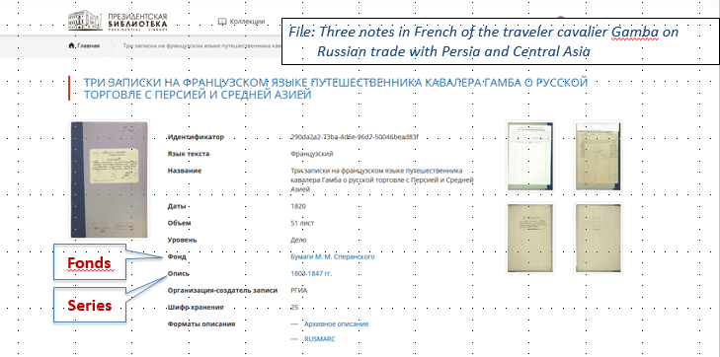

For example, see the record for the file “*Three notes in French of the traveler cavalier Gamba on Russian trade with Persia and Central Asia*” (see figure above). Immediately from the record the user may switch to viewing the record for the series or fonds. In the example – you may see links to series “1803-1847” and fonds “Papers of M.M. Speransky”.

Every archival record may displayed in one of three formats: full format (with text representation of MARC tags), archival format (brief record with arhive-specific fields) and full RUSMARC record for professional users.

So we have integrated catalogue of the Presidential Library, which allows to make user search most effective. Archival and traditional library materials complement each other; inclusion of archival catalog records in integrated online catalogs would enable our users to locate archival resources more easily.