Challenges of IranMARC implementation
Project Manager, National Library Integrated Software (RASA)

National Library of Iran launched IRANMARC plan in 1997 to make its bibliographic information compatible to international standards. After evaluating USMARC and UNIMARC, and considering the needs of the organization, UNIMARC was selected as a reference for IRANMARC for edition. Afterwards, IRANMARC’s handbook was provided as National Library of Iran’s first experience to write monographs.
Before 2000, NLI was using 35 separate databases to store bibliographic data of book and non-book documents, storing about 2000000 documents.
In 2003, NLI launched the Project of National Library Integrated Software called (RASA) to create an integrated system for completing NLI’s work processes and storing all library materials according to international standards in order to provide the possibility of easy exchange of data between the NLI and other libraries at national and international levels.
The implementation of MARC in the NLI’s integrated library system featuring 5% of the system’s capabilities will be outlined as follow:
There were at least 3 workgroups required for implementation of MARC standard:
- Professors in the field of Library and Information Science with complete mastery of the related standards;
- Information Technology and programming experts;
- Interdisciplinary experts who are able to make the two mentioned groups more understandable to each other;
The first step was to design and create the four UNIMARC formats databases (Bibliographic, Authority, Holdings and classification). Regardless of substantial differences between these formats, they were similar to each other in design and implementation.
For this we require an environment in which the system administrator could be easily able to create four main types of files inside any of those UNIMARC formats as follows:
- The Field Definition Table (FDT) in which the system administrator defines all the necessary fields and set their characteristics like tag, label, length, repeatability, authority Mandatory, type and…
- The worksheet, a sort of form where appear defined fields; it makes it possible to create and edit records.
- The Field Selection Table (FST) defining fields where search terms are extracted from, and the techniques used for the extraction.
- The format where are specified commands that output records for displaying on the screen or printing to the printer or to a file.
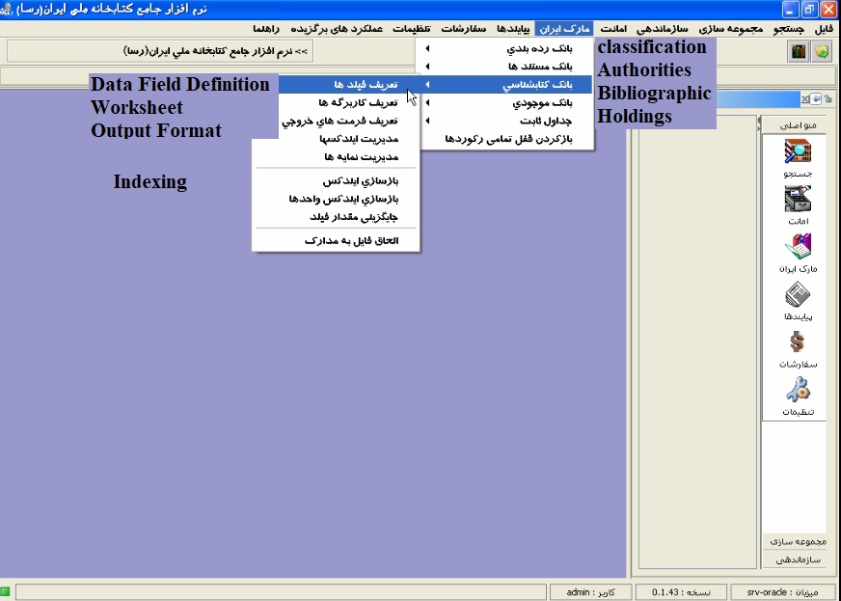
The following Characteristics for each MARC field have been defined in the IRANMARC database:

- Tag;
- label (in Persian and in English);
- Repeatable or Not;
- Mandatory or Not;
- Length
- Field Type (simple field, fixed length coded field, field related to the same bank/related to other banks (if related to other banks: to specify the related bank, field and subfield)
- The possibility of defining a help center (to insert a hypertext address that guides the user directly while data insertion. It can be a local file or an address file from another website like: IFLA);
- Indicator (in Persian and in English);
- Subfield;
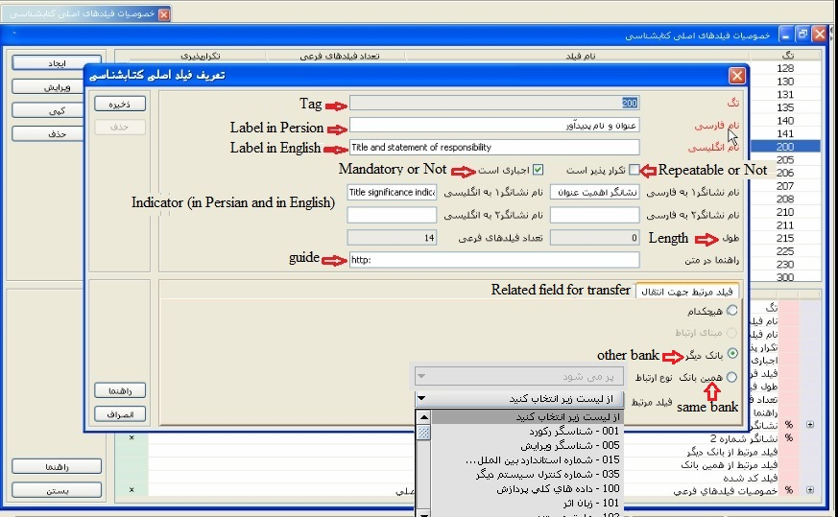

After that subfields were defined for every single Marc field with the following Characteristics:
- subfield code;
- label (in Persian and in English);
- Repeatable or Not;
- Mandatory or Not;
- Length;
- Subfield Type (simple subfield, fixed length coded subfield, subfield related to the same bank/related to other banks (if related to other banks: to specify the related bank, field and subfield) Subfield related to constant table
)Constant Table is a kind of UNIMARC table that is designed to integrate information, and is unique to a specific code. Selecting the code or element in the storage process is done by the user (
- Subfield arrangement (primary arrangement is formed based on the order of subfields creation automatically, however the manager of the system can change this order to any other desired arrangement);
- The possibility of defining subfield default value in Persian and in English
- The possibility of defining ISBD prefix for the subfield in Persian and in English (this is not one of specifications of MARC subfield and it is added in this software);
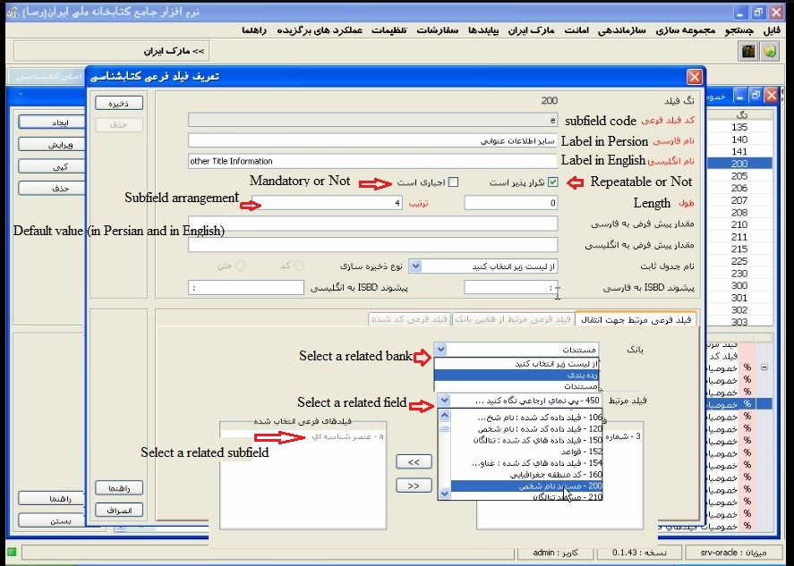
In accordance with above explanations, it is clear that constant tables, classification and authority banks were defined in the system before, in order to provide the possibility of making required linking in defining bibliographic bank.
Required fields to use in NLI were created in block 9 of IRANMARC. Fields of this block are not used for international exchange. For instance, related fields for controlling access levels and change history were added in block 9.
Only UNIMARC databases were thoroughly defined and required fields for IRANMARC were defined in spots allowed by the standard at this step. An environment was created at the next step to define and design worksheets based on the four formats including bibliographic, authority, classification and holding in order to provide the possibility of defining deferent worksheets for each document depending on the organization's needs.
Separating of document types in UNIMARC takes place using UNIMARC record labels and General Material Designation (GMD) and if it was required to assign a lower level for separating document types, a filed would be defined in block 9 with this aim.
Another possibility provided in worksheet definition section was the creation of Several worksheets in deferent levels (for example: simple, average and advanced) for any type of document in order to make the required worksheets available for the user, if one document’s data is supposed to be added in deferent times and by deferent users.
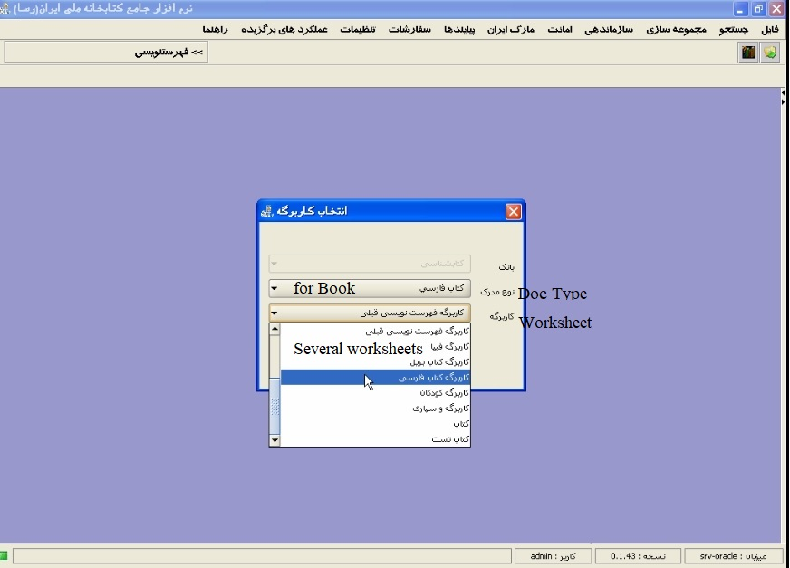
Advantages of UNIMARC:
- Easy to use when data entry
- Controlling access level to one record’s data;
- Final control and publishing permit;
Another facility implemented in the software was to add ISBD signs to bibliographic record automatically when saving records. These signs are the same signs that were created when each subfield was being defined in the system.
- It doesn’t engage the user with inserting these signs correctly;
- It is not necessary to change the program code if any change would be made in ISBD signs and if these sings change, this change will be saved in subfields definition section by the manager of the system and new records would be saved with new signs.
The connection between bibliographic and authorities databases in NLAI’s comprehensive system is useful, because each authority would be created in the system once, and will be used in thousands of records. Also, when each authority’s name is edited in authorities’ database, it will be edited in all related bibliographic records too; since the record number will be recalled along with the authority’s name in the bibliographic record.
Another advantage of the authorities’ database is that if the user would inset a non-preferred term while searching the system, the system first converts it into a preferred term and then searches it within the system.
At this point, MARC structure and worksheets were designed and the next challenge was to find a way to store data into the database. How can data bank be designed for records with unknown number of fields, unknown subfields and unknown data length for each field? ISO2709 standard was used to store data, in this way: one text field without data length limit was considered in the database so that all the data related to one record would be stored as ISO inside it. Besides, common fields that are used in correction table and search result summary display would be separately stored in the database. Given that each record length for an ISO record have to be 99999 according to the standards, and storage takes place based on Unicode (in Unicode each character needs two bytes of space and this limits us to only records with total characters of under 50000), hence the NLI has foreseen XML storage to rectify this issue. Nonetheless, there is still a problem with receiving output from this ISO format record and international organizations should proceed to resolve this problem.
After this, there was a database which was capable of storing bibliographic data, holding, authorities and classification based on IRANMARC standard (based on UNI MARC). Now the first step had been taken based on the standard and the next step was to create mappings for every 35 databases in order to store 2,000,000 records into the database according to IRANMARC.

